

Welcome to the latest edition of the
DDHR Advice for the Boss
newsletter

Benefits of Staff Training
This is Part 2 of our Staff Engagement and Training.
This edition is all about Staff Training

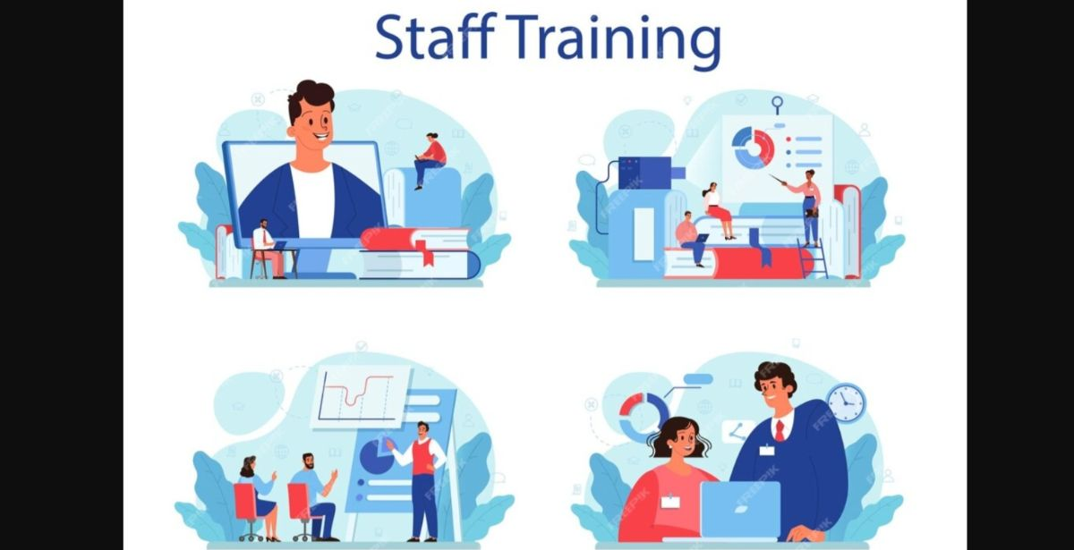

Enhancing Growth, Productivity, and Morale
Staff training is a cornerstone of organisational success, playing a pivotal role in equipping employees with the skills and knowledge necessary to perform their tasks effectively and adapt to changing demands. The benefits of staff training are outlined below, covering its impact on individual growth, team dynamics, and the needs of your business.

Professional Development
Staff training fosters professional growth by enhancing employees' existing skills and introducing them to new ones. This ensures they are prepared to meet evolving responsibilities and challenges. Professional development allows employees to:
- Improve job performance: With targeted training programs, employees can refine their abilities, leading to greater efficiency and accuracy in their roles.
- Stay up to date: With constant changes, training ensures employees are informed about the latest technologies, methodologies, and trends.
- Career prospects: Skills acquired through training can open doors for promotions or lateral moves within the company.
Boosting Employee Morale
Training sessions create an environment where employees feel valued and supported, directly contributing to their morale. Some of the ways staff training enhances morale include:
- Sense of appreciation: Employees view investment in their growth as a sign that the company values their contributions.
- Increased confidence: Acquiring new skills boosts self-assurance, empowering employees to tackle challenges with enthusiasm.
- Team-building benefits: Collaborative training sessions foster camaraderie and create a more cohesive workforce.
Enhancing Productivity
Training is an essential driver of productivity, ensuring that employees can perform their tasks efficiently and consistently. It achieves this by:
- Reducing errors: Well-trained staff are less likely to make mistakes, leading to smoother operations.
- Streamlining workflows: Training can introduce employees to tools and techniques that optimise their work processes.
- Improving output quality: Employees with strong skills deliver higher-quality results, directly impacting customer satisfaction.
Adaptability in a Changing World
In today's challenging environment, businesses must adapt to change rapidly. Staff training equips employees to manage transitions effectively, such as:
- Implementing new technologies: Training prepares employees to use modern tools and platforms, ensuring seamless integration.
- Responding to market shifts: Employees trained in customer relations are better positioned to address shifts in demand.
- Navigating organisational changes: From restructuring to policy updates, training smooths the transition process.
Retention and Employee Loyalty
A well-trained workforce is more likely to remain loyal to your business, reducing turnover rates. Benefits include:
- Greater job satisfaction: Feeling equipped to excel in their roles leads to higher levels of employee satisfaction.
- Reduced recruitment costs: Retaining skilled employees through training minimises the need for frequent hiring.
- Building long-term relationships: Continuous development fosters deeper connections between employees and their employers.
Leadership and Succession Planning
Training is a critical component in cultivating future leaders within a company. It ensures a pipeline of qualified individuals ready to step into managerial and executive roles. This is achieved through:
- Leadership development: Training programs focus on building decision-making, communication, and strategic thinking skills.
- Succession planning: Preparing employees for higher roles ensures smooth transitions during retirements or organisational changes.
- Empowering autonomy: Skilled employees can take initiative, reducing the burden on leadership teams.
Compliance and Risk Mitigation
In many industries, adhering to regulations and maintaining safety standards is non-negotiable. Training helps safeguard the organisation by:
- Ensuring legal compliance: Employees learn about regulations, reducing the risk of violations.
- Promoting workplace safety: Safety training mitigates risks and creates a secure environment.
- Reducing liability: Professionally trained staff minimise the likelihood of incidents that could lead to legal or financial repercussions.
Innovation and Creativity
Training encourages employees to think critically and creatively, fostering innovation within the organisation. It helps:
- Inspire new ideas: Exposure to diverse concepts and strategies during training sessions can spark innovation.
- Enhance problem-solving: Employees who are trained extensively are better equipped to tackle complex challenges.
- Competitive advantage: Organisations that invest in innovation-oriented training often stand out in their industries.

Cost Efficiency
While training involves upfront investment, the long-term benefits outweigh the costs. Training leads to:
- Operational savings: Efficient employees reduce waste and optimise resource use.
- Improved customer retention: High-quality service from trained employees leads to repeat business.
- Enhanced profitability: Skilled workers contribute to better overall financial performance.
Conclusion
Staff training is not merely an organisational task—it is an investment in the future. From professional growth to morale and productivity, its benefits are far-reaching and essential in an increasingly dynamic workplace. By fostering a culture of continuous learning and improvement, companies not only empower their employees but also position themselves as leaders in their respective fields.



Any questions you have click here
email Dermot
and we will respond accordingly
or call Dermot 086 843 6361

UPDATE
Ireland's new pension auto-enrolment system, originally set to commence on 30 September 2025, has now been postponed until January 2026 to allow additional time for the implementation of necessary systems and infrastructure.
The Auto-Enrolment Pension Scheme is a government initiative designed to increase retirement savings among the workforce. It will be fully operational by 1st January 2026 and will apply to employees who:
Are aged 23 to 60
Earn €20,000 or more per year
Are not already enrolled in a workplace pension scheme
Eligible employees will be automatically enrolled in the new scheme, known as My Future Fund, unless they are already contributing to a qualifying pension through payroll.

Now that you have read our newsletter we would appreciate it if you could please share it with others. By you sharing this it means more people gets to see our information and makes this newsletter a success. This in turn benefits you as we can put more resources into our editions giving you more useful HR content.

