

Welcome to the latest edition of the
DDHR Advice for the Boss
newsletter

The Intersection of Staff Engagement and Training
Building a Thriving Workforce

This edition of our newsletter focuses on staff engagement only.
Part 2 will focus on Staff Training and will be sent out next week
These twin pillars shape employees' morale and productivity and define the trajectory of the company’s achievements.
Engaged employees are the cornerstone of innovation and resilience, while effective training unlocks their potential.
Together, they create a symbiotic relationship where motivation meets competency, fostering a culture of continuous growth and mutual investment.
This article delves into the intricate connection between staff engagement and training, exploring strategies to cultivate a workforce that is not only skilled but also deeply committed to your business.

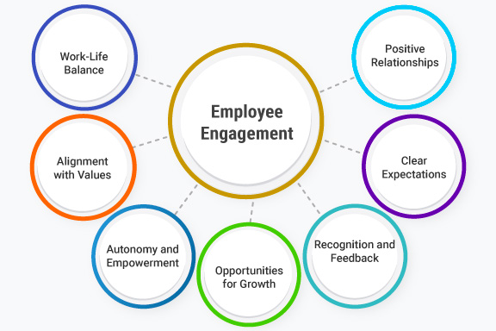

Staff Engagement
Unlocking Potential Through Connection and Commitment
Introduction
In today’s competitive business landscape, organisations are increasingly recognising the critical role of staff engagement in driving performance, innovation, and long-term success. Staff engagement goes beyond mere job satisfaction; it reflects the emotional commitment and enthusiasm employees feel toward their work and their employer. When employees are engaged, they are more likely to embrace challenges and contribute meaningfully to their organisation’s goals. In this article we explore the fundamentals of staff engagement, its importance, and strategies to cultivate a thriving, engaged workforce.
The Pillars of Staff Engagement
Defined Purpose and Meaningful Work
One of the primary drivers of staff engagement is the sense of purpose employees derive from their work. Employees who understand how their contributions align with the organisation’s mission and values are more likely to feel motivated and connected to their roles. A clear sense of purpose empowers employees by showing them that they are part of something larger than themselves.
Empowerment and Autonomy
Engagement flourishes when employees are trusted to make decisions and take ownership of their responsibilities. Empowering staff through autonomy fosters a sense of confidence and competence, enabling them to explore innovative solutions and grow professionally. Micromanagement, by contrast, can stifle creativity and breed disengagement.
Recognition and Appreciation
Employees who feel valued are naturally more engaged. Regular recognition of achievements, whether through formal awards or simple expressions of gratitude, reinforces a positive feedback loop. Celebrating successes, both big and small, demonstrates that the organisation appreciates its people and their contributions.
Opportunities for Growth
Engaged employees are often those who see a future for themselves within their organisation. Providing opportunities for learning, skill development, and career progression not only enhances employee capabilities but also signals the organisation’s investment in their long-term success.
Strong Leadership and Communication
Leadership plays a pivotal role in shaping the employee experience. Transparent communication, accessible leadership, and a clear vision foster trust and alignment. Leaders who actively listen to their teams and provide consistent support create an environment where engagement can thrive.
The Benefits of Staff Engagement
Enhanced Productivity
Engaged employees are more productive, as they are intrinsically motivated to perform at their best. They are more likely to go beyond their job descriptions, contributing to higher efficiency and stronger results.
Improved Retention
High levels of engagement can significantly reduce turnover rates. Employees who feel connected to their organisation are less likely to seek opportunities elsewhere, saving companies substantial costs associated with recruitment and training.
Better Customer Experience
Engaged employees are often brand ambassadors who take pride in delivering exceptional service. Their positive attitudes and energy are reflected in their interactions with clients, fostering loyalty and satisfaction.
Greater Innovation
When employees feel empowered and supported, they are more likely to take risks and propose creative ideas. Engagement fuels a culture of innovation, enabling organisations to adapt and stay ahead in a rapidly changing world.
A Positive Organizational Climate
Staff engagement contributes to a vibrant and collaborative workplace culture. Such environments inspire teamwork, resilience, and a shared sense of purpose.
Strategies to Boost Staff Engagement
Regular Feedback and Dialogue
Establishing open channels for feedback demonstrates that the organisation values employee input. Leaders should prioritise regular one-on-one conversations, performance reviews, and anonymous surveys to understand employees’ concerns and aspirations.
Prioritize Well-being
Well-being is integral to engagement. Organisations should promote work-life balance, provide access to mental health resources, and create flexible policies to support employees’ physical and emotional needs. A workforce that feels cared for is more likely to stay motivated and committed.
Foster Inclusion and Belonging
A diverse and inclusive environment where employees feel valued for their unique perspectives boosts engagement. Efforts to eliminate bias, embrace equity, and foster belonging ensure that all employees can thrive and contribute authentically.
Create Clear Goals and Expectations
Employees are most engaged when they know what is expected of them and how their performance contributes to broader organisational objectives. Establishing clear, measurable goals provides direction and fosters a sense of accomplishment.
Conclusion
Staff engagement is not a one-size-fits-all initiative—it requires a tailored and sustained effort that aligns with organisational values and employee needs. By cultivating an environment where employees feel valued, connected, and inspired, organisations can unlock the full potential of their workforce and achieve unparalleled success. As the workplace continues to evolve, prioritising staff engagement will remain a cornerstone of resilience and growth where every employee feels empowered to contribute, innovate, and excel.

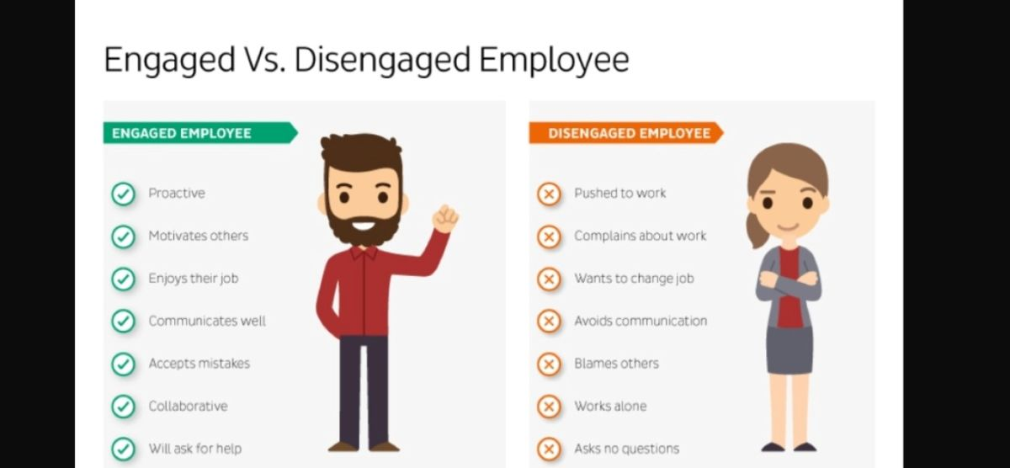

Any questions you have click here
email Dermot
and we will respond accordingly
or call Dermot 086 843 6361



Please click below to read this editions WRC case study and the consequences to the employer

Click to Read

Email DDHR
We can help you ensure your contracts and policies are up to date with current HR Legislation or if you have any other queries or questions click on our email link above.

Please call us for a chat on any issue
Dermot 086 8436361
dermot@ddhrsupportandadvice.com
Marie 085 1736722
marie@ddhrsupportandadvice.net

Now that you have read our newsletter we would appreciate it if you could please share it with others. By you sharing this it means more people gets to see our information and makes this newsletter a success. This in turn benefits you as we can put more resources into our editions giving you more useful HR content.

